**Sales Trend Analyzer**

A PROJECT REPORT

*Submitted by*

Jitender Kumar Giri

(22BCA11176)

***in partial fulfilment for the award of the degree of***

**BACHELOR OF COMPUTER APPLICATION**



Chandigarh University

April 2025



BONAFIDE CERTIFICATE

Certified that this project report  **Sales Trend Analyzer** is the bonafide work of “

**Jitender Kumar Giri** who carried out the

project work under my/oursupervision.

**SIGNATURE** **SIGNATURE**

**Dr. Kavita Gupta**  **Simranjeet Singh (E16232)**

**HEAD OF THE DEPARTMENT** **SUPERVISOR**

BCA

Submitted for the project viva-voce examination held on ………………………….



1. **Abstract……………………………………………………………………………….**
2. **Demo and Code………………………………………………………………….**
3. **Project Objectives………………………………………………………………….**
4. **Technologies Implemented………………………………………………………**
5. **Project Features………………………………………………………………………**
6. **Development Process……………………………………………………………….**
7. **Conclusion…………………………………………………………………………..**

**Abstract**

The **Sales Trend Analyzer** is a mini-project developed for the **Data Interpretation Lab**, focused on understanding and visualizing sales trends using **Microsoft Excel**. The project analyzers daily sales data collected over a span of six months (January to June 2022). The data comprises two major product categories: Electronics and Furniture.

With a small dataset of 12 records, this project utilizes Excel’s capabilities like tables, charts, conditional formatting, and formulas to identify trends, observe fluctuations, and compare category-wise performance. The project reflects how Excel can serve as a powerful tool in generating insights even from a limited dataset — empowering better decision-making in business environments without requiring any programming skills.

**Demo and Code**

This project does not require traditional programming. All analysis is done using the **features built into Microsoft Excel**. Below is a breakdown of the implementation:

**Dataset Information**

- Table Name: `sales_data`

- Range: A1 to D14

- Columns:

- Date: Daily entries (Jan to June 2022)

- Product: Name of the item sold

- Category: Electronics or Furniture

- Sales: Sales amount in USD

**Charts Used**

1. Monthly Sales Trend (Line Chart)

- Shows variation in sales over time

- X-axis: Dates from Jan to June

- Y-axis: Sales values

2. Category-wise Sales Analysis (Bar Chart)

- Compares total sales of Electronics vs Furniture

- Color-coded bars for easy interpretation

Excel Features & Formulas

- `=SUM()` – Total sales calculation

- `=AVERAGE()` – Average sales value

- Conditional Formatting – Highlights high/low sales

- Filter and Sort – For category-wise viewing

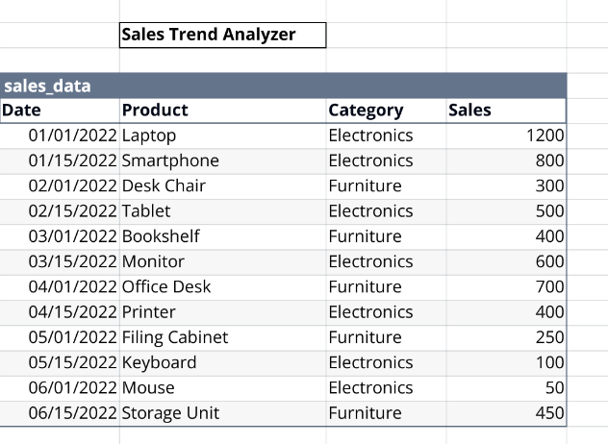

**Project Objectives**

The main objectives of the **Sales Trend Analyzer** are:

- To analyze daily and monthly sales data using Excel.

- To build analytical thinking using basic data interpretation.

- To visualize sales performance and trends through charts.

- To compare sales of Electronics and Furniture categories.

- To apply Excel functions like `SUM` and `AVERAGE` for analysis.

- To demonstrate how simple tools can provide useful business insights.

This project emphasizes the importance of visual data analysis for drawing meaningful conclusions from raw datasets.

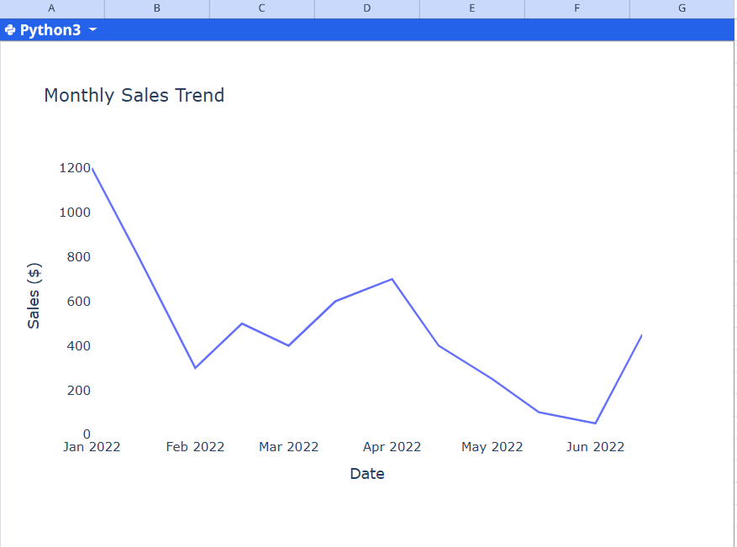

**Technologies Implemented**

This project makes use of **Microsoft Excel** exclusively. It shows how even a non-programming tool can be powerful in analyzing and presenting data.

**Tools Used**

- Microsoft Excel (2016 or later)

- Excel Tables

- Line Chart and Bar Chart

- Conditional Formatting

- Filter/Sort features

- Formula Bar (`SUM`, `AVERAGE`)

**System Requirements**

- OS: Windows 10 or 11

- Software: Microsoft Excel

- Minimum RAM: 4GB

- Screen resolution: 1366x768 or higher

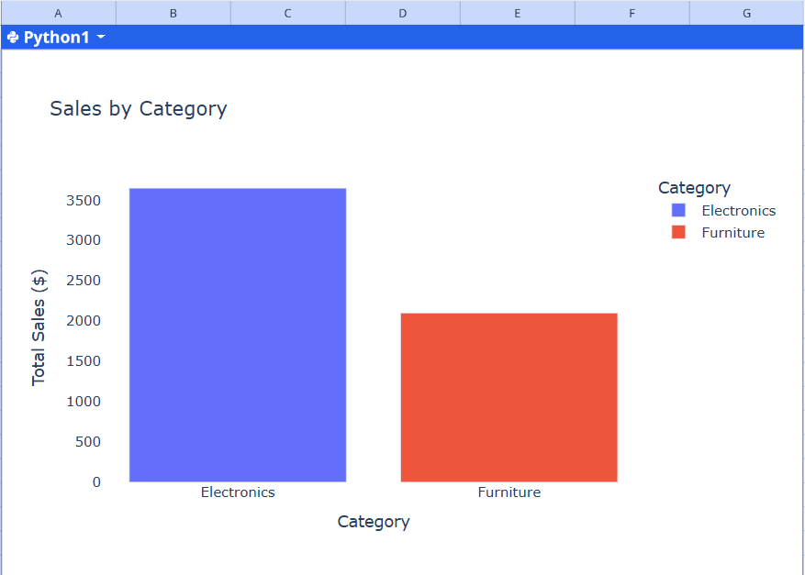

**Project Features**

The project contains multiple features that enhance both usability and readability:

- Structured Table: All records are organized for quick access.

- Interactive Charts: Graphs auto-update when data changes.

- Comparison Graph: Easily understand category-wise revenue performance.

- Color-Coding: Use of conditional formatting for visual emphasis.

- Easy Navigation: Filters help sort by Date, Category, or Product.

- User Friendly : Designed for anyone to understand without technical knowledge.

**Development Process**

The creation of the Sales Trend Analyzer followed a step-by-step approach:

1. Dataset Preparation

- Created a 12-entry table of daily sales for 6 months (Jan–June 2022).

2. Excel Table Formatting

- Applied table formatting for clarity and organization.

3. Formula Integration

- Used Excel formulas for calculating totals and averages.

4. Chart Design

- Designed a Line Chart for temporal sales fluctuation.

- Created a Bar Chart for category-wise comparison.

5. Visualization Enhancements

- Applied Conditional Formatting to highlight high and low sales.

- Color-coded categories for better distinction in charts.

6. Testing & Review

- Verified calculations and charts for accuracy.

- Analyzed insights based on visual data.

**Conclusion**

The **Sales Trend Analyzer** project successfully demonstrates how Microsoft Excel can be used for data interpretation and visualization. Without writing a single line of code, powerful insights were obtained from a simple dataset.

Key achievements include:

- Understanding fluctuations in monthly sales

- Comparing category-wise revenue performance

- Learning Excel’s core data tools

This project not only strengthens basic Excel skills but also improves business awareness by showing how even small datasets can provide valuable insights. It serves as a practical example of how simple software tools can be applied in real-world data analytics tasks.